December 27, 2006

Jóhanna Margrét Thorlacius
Icelandic Meteorological Office
Bústaðavegur 9
IS-105 Reykjavík, Iceland

Dear Johanna,

I would like to send along my best wishes to Oskar, the site operator at Storhofdi, on his retirement and join in thanking him for his many years of excellent service. I am involved with several monitoring sites in the U.S. and I know very well how important it is to have a conscientious and skilled operator. Indeed, the integrity of the data depends on it.

I understand that a decision has not been made yet regarding the continuity of operations at the site. The data collected at the Storhofdi site is of immense scientific value, and I truly hope that the activities can continue after Oskar retires. There are too few sites in the world that provide a long-term data record such as that generated at Storhofdi and the loss of critical measurements at any such site would be very unfortunate.

The data collected at Storhofdi is important to my work and the work of others. For example, atmospheric modelers like myself use the data to “ground truth” our models, i.e., to determine if we are getting the right answer or not. As our level of understanding is still very limited, the measurement data are absolutely essential if we are to continue to make progress. Modelers like myself hope to be able to someday provide reliable information about such topics as source-attribution for observed atmospheric parameters – i.e., where does it come from? – but we will never get there without continued data from stations like Storhofdi.

In sum, I offer best wishes and thanks to Oskar, and I fervently hope that the full range of activities at “his” site will be able to be continued after his retirement.

Best wishes,
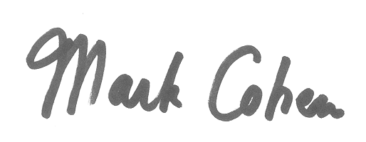
Mark Cohen, Ph.D.
Physical Scientist
NOAA Air Resources Laboratory

