UNITED STATES DEPARTMENT OF COMMERCE National Oceanic and Atmospheric Administration
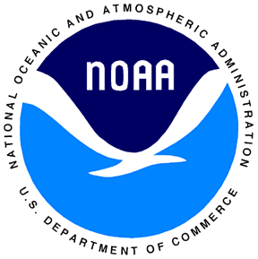
Earth System Research Laboratory
Global Monitoring Division
325 Broadway – David Skaggs Research Center
Boulder, Colorado 80305 USA

January 19, 2007

Johanna Margret Thorlacius
Vedurstofa Islands
Bustadavegur 9
IS-105 Reykjavik, Iceland

Dear Johanna,

In the back of our minds we knew that someday in the not too distant future Oskar would retire and we would be faced with the prospect of finding a new arrangement for continuing the vital measurements at Storhofdi. It is hard to believe that it has been nearly 15 years ago that we began our collaboration with Vedurstofa Islands to do air sampling at Storhofdi. Oskar’s very able and dedicated work has been crucial in obtaining the time series of surface ozone and flask samples that are now a vital link in the NOAA Earth System Research Laboratory (formerly CMDL) global network for detecting and understanding long-term climate change. We are very appreciative of, and highly value, the effort of Verdurstofa Islands in this vital monitoring and research effort. With an increasing emphasis on controlling greenhouse gas emissions even here in the U.S., these observations will take on an even higher priority as they will be one of the primary means of verifying any control measures. We are anxious to work with the Vedurstofa to find a way of continuing the measurements at Storhofdi. I also want to thank you personally for your dedication to the projects at Storhofdi and for seeking to ensure the continuation of measurements at this site.

Best regards,

(signed)

Samuel J. Oltmans
Chief, Ozone and Water Vapor Group

