
December 19, 2006
Environment Environnement
Canada Canada

Johanna M. Thorlacius
Icelandic Meteorological Office
Bustadavegur 9
IS-150 Reykjavik
Iceland

Dear Johanna,

As you are aware, the Global Atmospheric Passive sampling (GAPS) pilot study has been extended to a full global network that will continue until at least 2010. This network will provide valuable information to be used as part of the Global Monitoring Plan of the Stockholm Convention on POPs (persistent organic pollutants) to assess ‘effectiveness’ of this convention on reducing the environmental burden of these chemicals.

The success and further adoption of GAPS by the United Nations Environment Program (UNEP) is due largely to the cost-effective nature of this program. This aspect is only made possible by participants such as yourself and your group that contribute to sample collection under GAPS.

I would like to take this opportunity to acknowledge your support and the work of the attendand at the Storhofdi site, Oskar. Continued sampling at Storhofdi would mean a lot to the GAPS effort and would contribute to the larger international effort under the Stockholm Convention.

Best wishes,
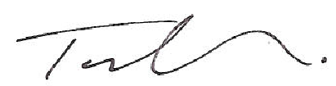

Tom Harner, Ph.D., P.Eng.
tel. 416 739 4837; tom.harner@ec.gc.ca

